**VINAYA SV**

**727721EUIT178**

**DAY 7 TESTNG**

**Class Exercise 1:**

| package com.Day7.Day7CE;  import org.openqa.selenium.WebDriver; import org.openqa.selenium.chrome.ChromeDriver; import org.openqa.selenium.chrome.ChromeOptions; import org.testng.Assert; import org.testng.annotations.Test;  import io.github.bonigarcia.wdm.WebDriverManager;  public class ClassExercise1 {  @Test  public void f() {  ChromeOptions co=new ChromeOptions();  co.addArguments("--remote-allow-origins=*");  WebDriverManager.chromedriver().setup();  WebDriver driver=new ChromeDriver(co);  driver.navigate().to("https://demo.wpeverest.com/user-registration/guest-registration-form/");  String actual=driver.getTitle();  String expected="Guest Registration Form - User Registration";  Assert.assertEquals(actual,expected);  } } |
| --- |

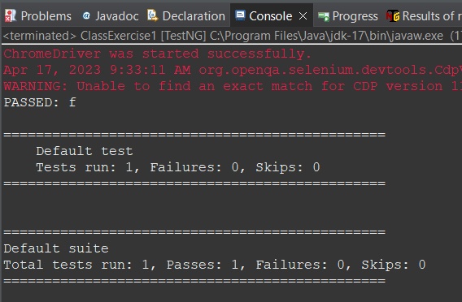

**Class Exercise 2:**

| package com.Day7.Day7CE;  import org.testng.Assert; import org.testng.annotations.Test;  public class ClassExercise2 {  @Test(priority=1)  public void add() {  int num1=10;  int num2=20;  int result=num1+num2;  Assert.assertEquals(result,30);  }    @Test(priority=2)  public void subtract() {  int num1=30;  int num2=10;  int result=num1-num2;  Assert.assertEquals(result, 20);  }    @Test(priority=3)  public void multiply() {  int num1=10;  int num2=30;  int result=num1*num2;  Assert.assertEquals(result, 300);  }    @Test(priority=4)  public void divide() {  int num1=30;  int num2=10;  int result=num1/num2;  Assert.assertEquals(result, 3);  } } |
| --- |

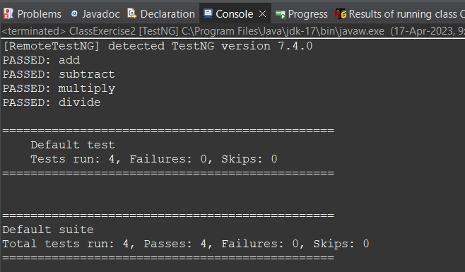

**Class Exercise 3:**

| package com.Day7.Day7CE;  import org.testng.annotations.Test;  import io.github.bonigarcia.wdm.WebDriverManager;  import org.testng.annotations.BeforeMethod; import org.openqa.selenium.By; import org.openqa.selenium.WebDriver; import org.openqa.selenium.chrome.ChromeDriver; import org.openqa.selenium.chrome.ChromeOptions; import org.testng.Assert; import org.testng.annotations.AfterMethod;  public class ClassExercise3 {  WebDriver driver;  @Test  public void Verification() throws InterruptedException {  Thread.sleep(3000);  driver.findElement(By.xpath("//input[@name='username']")).sendKeys("Admin");  driver.findElement(By.xpath("//input[@name='password']")).sendKeys("admin123");  driver.findElement(By.xpath("//*[@id=\"app\"]/div[1]/div/div[1]/div/div[2]/div[2]/form/div[3]/button")).click();  Thread.sleep(3000);  Assert.assertEquals(driver.findElement(By.xpath("//h6[@class=\"oxd-text oxd-text--h6 oxd-topbar-header-breadcrumb-module\"]")).getText(),"Dashboard");    }    @BeforeMethod  public void beforeMethod() {  ChromeOptions co=new ChromeOptions();  co.addArguments("--remote-allow-origins=*");  WebDriverManager.chromedriver().setup();  driver=new ChromeDriver(co);  driver.get("https://opensource-demo.orangehrmlive.com/web/index.php/auth/login");  driver.manage().window().maximize();  }    @AfterMethod  public void afterMethod() {  driver.close();  } |
| --- |

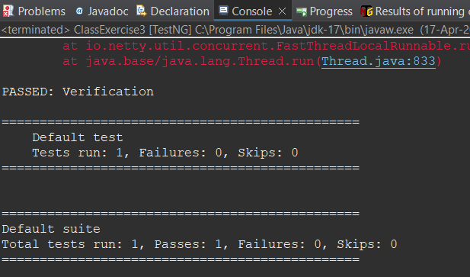

**Class Exercise 4:**

| **package com.Day7.Day7CE; import org.junit.BeforeClass; import org.openqa.selenium.By; import org.openqa.selenium.WebDriver; import org.openqa.selenium.chrome.ChromeDriver; import org.openqa.selenium.chrome.ChromeOptions; import org.testng.Assert; import org.testng.annotations.Test; import io.github.bonigarcia.wdm.WebDriverManager; public class ClassExercise4 {  WebDriver driver; @Test public void Login() throws InterruptedException {  ChromeOptions co=new ChromeOptions();  co.addArguments("--remote-allow-origins=*");  WebDriverManager.chromedriver().setup();  driver=new ChromeDriver(co);  driver.get("https://opensource-demo.orangehrmlive.com/web/index.php/auth/login");  driver.manage().window().maximize();  Thread.sleep(3000);  driver.findElement(By.xpath("//input[@name='username']")).sendKeys("Admin");  driver.findElement(By.xpath("//input[@name='password']")).sendKeys("admin123");  driver.findElement(By.xpath("//*[@id=\"app\"]/div[1]/div/div[1]/div/div[2]/div[2]/form/div[3]/button")).click();  Assert.assertEquals(driver.getCurrentUrl(),"https://opensource-demo.orangehrmlive.com/web/index.php/dashboard/index"); } @Test( dependsOnMethods=("Login")) public void Logout() throws InterruptedException {  Thread.sleep(3000);  driver.findElement(By.xpath("//span[@class=\"oxd-userdropdown-tab\"]")).click();  Thread.sleep(3000);  driver.findElement(By.xpath("//ul[@class=\"oxd-dropdown-menu\"]/li[4]/a")).click();    Assert.assertEquals(driver.getCurrentUrl(),"https://opensource-demo.orangehrmlive.com/web/index.php/auth/login"); } }** |
| --- |

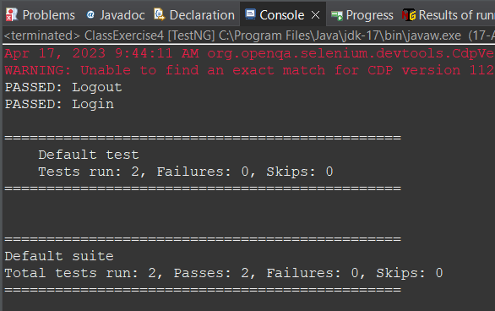

**Class Exercise 5:**

| **package com.Day7.Day7CE;  import org.testng.annotations.Test;  import io.github.bonigarcia.wdm.WebDriverManager;  import org.testng.annotations.BeforeMethod;  import java.util.concurrent.TimeUnit;  import org.openqa.selenium.By; import org.openqa.selenium.WebDriver; import org.openqa.selenium.chrome.ChromeDriver; import org.openqa.selenium.chrome.ChromeOptions; import org.testng.Assert; import org.testng.annotations.AfterMethod;  public class ClassExercise5 {  WebDriver driver;  @Test(groups = "smoke-test")  public void TestCase1() {  String actualTitle=driver.getTitle();  String expectTitle="Domain Names, Websites, Hosting & Online Marketing Tools - GoDaddy IN";  Assert.assertEquals(actualTitle, expectTitle);  String actualUrl=driver.getCurrentUrl();  String expectUrl="https://www.godaddy.com/en-in";  Assert.assertEquals(actualUrl, expectUrl);  }    @Test(groups = "regression-test")  public void TestCase2(){  driver.manage().timeouts().implicitlyWait(10, TimeUnit.SECONDS);  driver.findElement(By.xpath("//*[@id=\"id-631b049a-e9c0-4d24-8710-c504745206dd\"]/div[2]/div[1]/ul/li[1]/button")).click();  driver.findElement(By.xpath("//*[@id=\"id-631b049a-e9c0-4d24-8710-c504745206dd\"]/div[2]/div[1]/ul/li[1]/div/div[2]/div[1]/ul/li[2]/a")).click();    }    @Test(groups = "regression-test")  public void TestCase3() {  driver.manage().timeouts().implicitlyWait(10, TimeUnit.SECONDS);  driver.findElement(By.xpath("//*[@id=\"id-631b049a-e9c0-4d24-8710-c504745206dd\"]/div[2]/div[1]/ul/li[1]/button")).click();  driver.findElement(By.xpath("//*[@id=\"id-631b049a-e9c0-4d24-8710-c504745206dd\"]/div[2]/div[1]/ul/li[1]/div/div[2]/div[1]/ul/li[2]/a")).click();  String actualTitle=driver.getTitle();  System.out.println(actualTitle);    }  @BeforeMethod  public void beforeMethod() {  ChromeOptions co=new ChromeOptions();  co.addArguments("--remote-allow-origins=*");  WebDriverManager.chromedriver().setup();  driver=new ChromeDriver(co);  driver.get("https://www.godaddy.com/en-in");  driver.manage().window().maximize();  }   @AfterMethod  public void afterMethod() {  }  }** |
| --- |

